Do you want to learn a new programming language? How about a language that’s used by many of the world’s largest companies in thousands of applications? A language that has built several of the top video game engines? An Object-Oriented language built and supported by the engineers at Microsoft?

Let’s talk about C#, and the .NET framework.

While C# is the primary language you’ll use to do most of your work, the .NET framework is probably the more important part of the package.

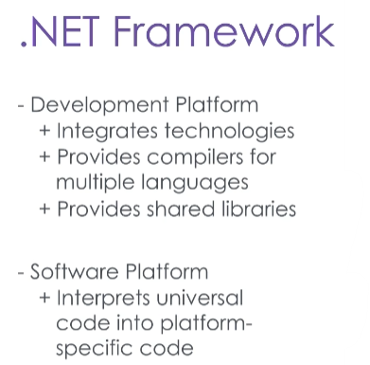**.NET provides an environment for both developing, and executing, applications.**

As a development platform, it integrates many different technologies like AJAX and O/RM. It has compilers for several languages like C#, Visual Basic, and more; and it also includes Base Class Libraries that provide commonly used functionality and which are shared between all languages in the platform.

As a software platform, it’s a virtual runtime environment that sits on top of an operating system to allow programs to run independently of that operating system, and independent of the language the application was written in.

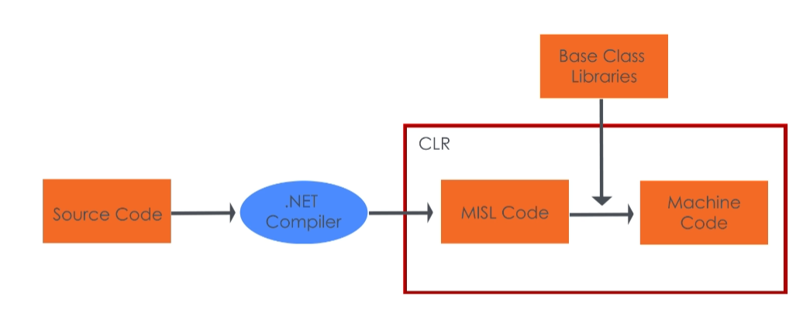

When you write code with any language in the .NET framework, it gets compiled into Microsoft Intermediate Language, or MSIL (“missile”) code. This MSIL code is then interpreted by the **Common Language Runtime** (**CLR**) which converts it into machine code during execution and feeds it to your computer.

The CLR is a virtual machine – software that shares resources like memory between all of the programs it’s executing.

Earlier, I called C# an Object Oriented language. What does that mean?

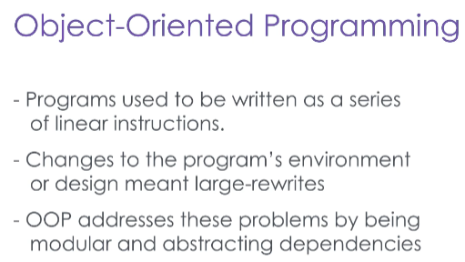Well, when you program source code for an application, you’re writing a series of instructions for your computer to perform. You can think of it like writing a movie script. In the old days, programs were written as a series of instructions that had to be followed exactly, in a precise order. A movie script like that might read, “Scene 1: It’s 3:43pm on a Tuesday in February in Chicago. Jim Carrey is sitting at a Starbucks, drinking a coffee.”

But what if you later decide that it’s not a good first scene, you can’t get Jim Carrey to play the part in your movie, Chicago won’t grant the permits to film there, and you can’t start filming until September? Wouldn’t it be easier to write the script to take place at any time in the afternoon, in any major American city, with any actor, in any coffee shop? And wouldn’t you like the freedom to move that scene to a later part of the movie?

Object Oriented programming is both a way of generalizing your application to run with different specific circumstances, and breaking your application into discrete components that can be combined in different ways.

You write classes, which are the general blueprints for your application, and from them you instantiate specific objects.

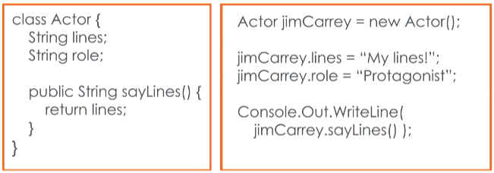An actor is a class, which has its own behaviors like “reciting lines” and its own properties like role and lines.

Jim Carrey is an instance of an actor – an object. He has a specific way of speaking his lines, and he plays the role of the protagonist and has his own specific lines.

You can have multiple Actors, each with their own specific details, but every actor will share the same basic behaviors, and have the same properties – even if the specific details of those properties are different.

To get started programming in C# and with the .NET framework, you’re going to want to download and install Microsoft Visual Studio.

Visual Studio is an Integrated Development Environment – an IDE – which incorporates all of the features and tools you could want for development into a single application.

If you continue watching, we’ll talk about all of the features that make C# such a powerful language, with plenty of examples.